title: “ANA 515 Week 5 Data Visualiation” author: “Dhairya Patel” date: “11/14/2021” output: html_document — raw_data <- read.csv(“<https://raw.githubusercontent.com/fivethirtyeight/data/master/births/US_births_1994-2003_CDC_NCHS.csv>”, fileEncoding = “UTF-8”)

install.packages(“tidyverse”) library(tidyverse)

ggplot(raw_data, aes(births)) + geom_area(stat = “bin”, bins = 30, fill = “orange”) + scale_x_continuous(breaks = seq(0,1993,2003))+ labs(title = “Birth rate in US”, x = “births”, y = “year”)

Read more at: <https://www.tatvic.com/blog/7-visualizations-learn-r/?utm_source=copytext&utm_medium=text&utm_campaign=textshare>

ggplot(data = raw_data) + geom_point(mapping = aes(x = births, y = year))

ggplot(raw_data, aes(year)) + geom_bar(fill = “orange”)+theme_bw()+ scale_x_continuous(“year”, breaks = seq(1993,2003)) + scale_y_continuous(“birth”, breaks = seq(0,150,1500)) + coord_flip()+ labs(title = “Birth rate in USA”) + theme_gray()

Read more at: <https://www.tatvic.com/blog/7-visualizations-learn-r/?utm_source=copytext&utm_medium=text&utm_campaign=textshare>

Read more at: <https://www.tatvic.com/blog/7-visualizations-learn-r/?utm_source=copytext&utm_medium=text&utm_campaign=textshare>

## R Markdown

This is an R Markdown document. Markdown is a simple formatting syntax for authoring HTML, PDF, and MS Word documents. For more details on using R Markdown see <http://rmarkdown.rstudio.com>.

When you click the **Knit** button a document will be generated that includes both content as well as the output of any embedded R code chunks within the document. You can embed an R code chunk like this:

summary(cars)

## speed dist   
## Min. : 4.0 Min. : 2.00   
## 1st Qu.:12.0 1st Qu.: 26.00   
## Median :15.0 Median : 36.00   
## Mean :15.4 Mean : 42.98   
## 3rd Qu.:19.0 3rd Qu.: 56.00   
## Max. :25.0 Max. :120.00

## Including Plots

You can also embed plots, for example:

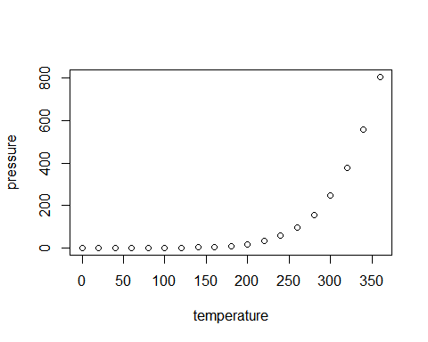

Note that the echo = FALSE parameter was added to the code chunk to prevent printing of the R code that generated the plot.